Unit 4: Gothic Art Supplemental

Golden Haggadah and Dedication Page with Blanche of Castile and King Louis IX of France and Scenes from the Apocalypse, from a Bible moralisée

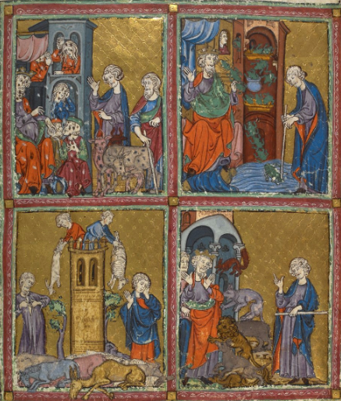
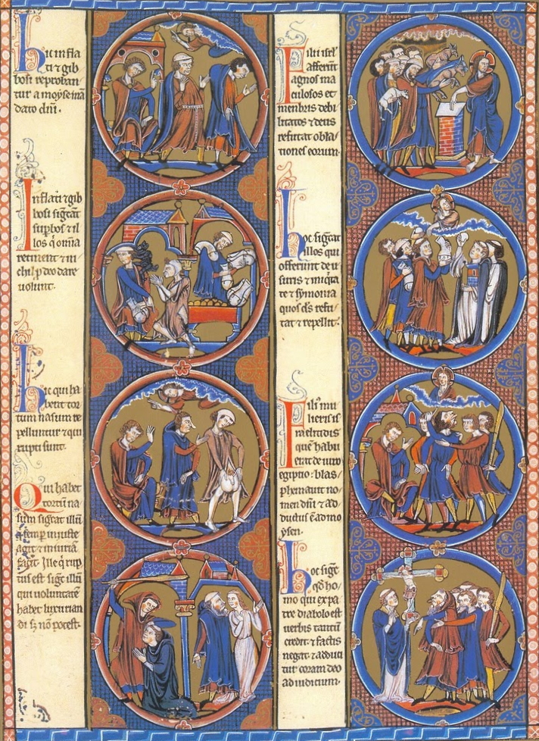

Golden Haggadah (The Plagues of Egypt, Scenes of Liberation, and Preparation for Passover). Late medieval Spain. c. 1320 C.E. Illuminated manuscript (pigments on vellum).

Golden Haggadah
The extravagant use of gold-leaf in the backgrounds of its 56 miniature paintings earned this magnificent manuscript its name: the 'Golden Haggadah'. It was made around 1320, in or near Barcelona, for the use of a wealthy Jewish family. The holy text is written on vellum pages in Hebrew script, reading from right to left. Its stunning miniatures illustrate stories from the biblical books of 'Genesis' and 'Exodus' and scenes of Jewish ritual.
What is a haggadah?
A haggadah is a collection of Jewish prayers and readings written to accompany the Passover 'seder', a ritual meal eaten on the eve of the Passover festival. The ritual meal was formalized during the 2nd century, after the example of the Greek 'symposium', in which philosophical debate was fortified by food and wine. The literal meaning of the Hebrew word 'haggadah' is a 'narration' or 'telling'. It refers to a command in the biblical book of 'Exodus', requiring Jews to "tell your son on that day: it is because of that which the Lord did for me when I came forth out of Egypt". Perhaps because it was mainly intended for use at home, and its purpose was educational, Jewish scribes and artists felt completely free to illustrate the Haggadah. Indeed it was traditionally the most lavishly decorated of all Jewish sacred writings, giving well-to-do Jews of the middle ages a chance to demonstrate their wealth and good taste as well as their piety. The man for whom the 'Golden Haggadah' was made must have been rich indeed.
What is Passover?
Passover commemorates one of the most important events in the story of the Jewish people. Like Christianity and Islam, Judaism traces its origins back to Abraham. He was leader of the Israelites, a group of nomadic tribes in the Middle East some 4,000 years ago. Abraham established a religion that distinguished itself from other local beliefs by having only one, all-powerful God. According to a Covenant made between them, the Jews would keep God's laws, and in return they would be protected as chosen people.
The Israelites were captured and taken as slaves to Egypt, where they suffered much hardship. Eventually, a prophet called Moses delivered the Jews from their captivity with the help of several miraculous events intended to intimidate the Egyptian authorities. The last of these was the sudden death of the eldest son in every family. Jewish households were spared by smearing lambs' blood above their doors - a sign telling the 'angel of death' to pass over.

Who made the Golden Haggadah?
The illumination of the manuscript - its paintings and decoration - was carried out by two artists. Though their names are unknown, the similarity of their styles implies they both worked in the same studio in the Barcelona region. The gothic style of northern French painting was a strong influence on Spanish illuminators, and these two were no exceptions. There is also Italian influence to be seen in the rendering of the background architecture. Differences between the two artists may be attributed to their individual talents and training. The painter of the scenes shown here tends towards stocky figures with rather exaggerated facial expressions. The second artist has a greater sense of refinement and achieves a better sense of space.
Why was a Jewish manuscript made in Spain?
The wandering tribes of Israel finally settled in the 'promised land' after their delivery from captivity in Egypt. But the twin kingdoms of Israel and Judah were to fall to the Assyrians and Babylonians. Then, in 63 BC, the region came under the governance of the Roman Empire. In 70 AD, the Roman army destroyed the Second Jewish Temple and sacked Jerusalem; in 135 AD they crushed a Judaean uprising. As a result of this many Jews went into exile. Some migrated across north Africa to Spain. For many centuries, these 'Sephardic' Jews lived peacefully and productively under both Christian and Islamic rulers. The Jewish community in Barcelona had been established since Roman times and was one of the most affluent in Spain by the time the 'Golden Haggadah' was produced. Jews acted as advisers, physicians and financiers to the Counts of Barcelona, who provided economic and social protection. They grew attuned to the tastes of the court and began commissioning manuscripts decorated in Christian style. Though the scribe who wrote its Hebrew text would have been a Jew, the illuminators of the 'Golden Haggadah' are likely to have been Christian artists, instructed in details of Judaic symbolism by the scribe or patron.
Scenes of the Haggadah
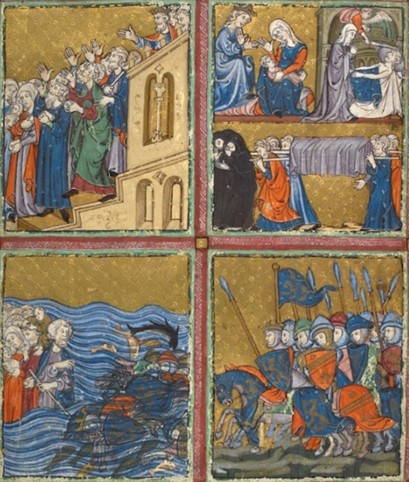
The Plagues of Egypt, folios 12v - 13. The ongoing conflict between Pharaoh and Moses culminates in a series of devastating plagues. Blighted by disasters, humans, animals, and nature are rendered by the second artist in the naturalistic manner specific to the northern French Gothic style. These miniatures display other distinctive marks of the artist's skill and style, such as the flowing drapery, and the well-proportioned figures with thick, wavy hair and expressive faces and gestures. Here the plague of frogs is initiated by Moses, not Aaron as indicated in the Bible. Green frogs leap everywhere and nobody is spared, not even Pharaoh. The plague of lice attacks both humans and animals, and Pharaoh and his magicians seem helpless. According to Jewish tradition, the plague of arov denotes wild beasts. Moses looks on as Pharaoh and his attendant are attacked by wild animals. In Latin manuscripts, this plague is usually the plague of flies. This panel shows the plague on livestock. The man wiping away tears, the man tearing his shirt, and the lifeless animals on the ground are realistically executed. In folio 13. Moses throws ashes out of a bowl, initiating the plague of boils. On the left, a barefoot Pharaoh covered with spots consults a physician. Two episodes are featured here: on the left a powerless Pharaoh watching the onset of the plague of hail and flaming fire; on the right, Moses, lifting his hands in prayer, asks God to stop the plague. Aaron looks on as Moses touches the ground with his staff and triggers the plague of locusts. There are two scenes based on midrashic legends: above, Pharaoh and his courtiers are immobilized by the plague of darkness, while, below, the Israelites carry away the Egyptians possessions.
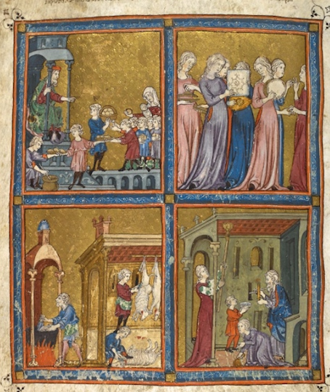
Liberation and Preparation, folios 14v - 15. In this last opening of the sequence of full-page miniatures, the artist concentrates on two themes: the Israelites' liberation and joyful departure from Egypt, and preparations for the Passover Festival. The artist's mastery of contemporary Italian techniques, aimed at creating space and depth, can best be seen in the miniatures on the left-hand page. Here, architectural backgrounds of niches, arched windows, coffered ceilings, and canopies create a distinct sense of space lacking elsewhere in the manuscript. This illustrates the plague of the first-born. In the upper-right scene, a man is struck by an angel's sword; in the left scene, the queen mourns her baby lying lifeless on a nurse's lap; the third scene, not recorded in the Bible, probably represents the funeral of the first-born. Pharaoh, on a battlement, orders the Israelites to leave Egypt. Followed by Moses, the Israelites, holding lumps of dough, walk with hands raised illustrating the verse: 'And the children of Israel went out with a high hand'. The pursuing Egyptians are depicted as contemporary knights led by a crowned king. The heraldic devices in Hebrew medieval manuscripts portrayed personal arms, but the impossibility of identification has reduced most of them to a purely decorative role. The Israelites' safe crossing of the Red Sea is shown. Moses, holding his rod, turns back and takes a last look at the drowning Egyptians. Miriam, Moses' sister, holding a timbrel decorated with an Islamic motif, is joined by maidens dancing and playing contemporary musical instruments. In this ritual scene of preparations for Passover, the master of the house, sitting under a canopy, orders the distribution of matsah (unleavened bread) and haroset (sweetmeats) to the children. A family prepares the house for Passover. The man holding a candle searches for leaven on the night before Passover, helped by a boy. The woman cleans the coffered ceiling, while a girl sweeps the floor. Sheep are slaughtered and prepared for Passover in the building on the right. Beneath a baldachin, a man purifies utensils in a cauldron over a fire.

Dedication Page with Blanche of Castile and King Louis IX of France and Scenes from the Apocalypse, from a Bible moralisée. Gothic Europe. c. 1226–1234 C.E. Illuminated manuscript (ink, tempera, and gold leaf on vellum).

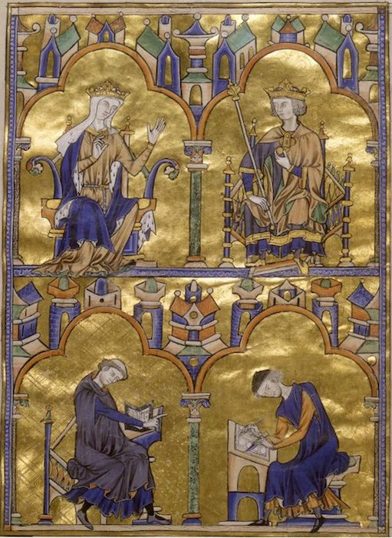
The sumptuous Bible made for Louis IX the Saint has been known for centuries under the name of Biblia rica (”rich Bible”) for its luxury decoration. It was transferred to Toledo during the lifetime of the King (1226–1270) where 8 folios were taken out for unknown reasons in the 16th century and rebound separately in leather. They have been kept in the Pierpont Library in New York since 1906. The faithful facsimile reproduction of these eight leaves serves not only the purpose of conservation and protection of a unique original, but also provides scholars and bibliophile amateurs access to this work, for those who are unable to visit the library in New York. The overall impression of this Bible manuscript is that of a lavishly decorated picture book, which is accessible even without reading the accompanying text. This codex thus belongs to a type of manuscripts unique to the early 13th century, the so-called Moralized Bibles. These Bible manuscripts with their wealth of miniatures conveyed a whole universe of picture narrative in the Middle Ages.
A characteristic feature of the Moralized Bibles of the early 13th century resides in the fact that both picture and text are always well balanced. Bible text and Bible commentary, Bible illustration and commentary illustration, appear side by side in a common context. As every text passage is explained by its own commentary, every Bible illustration is complete with a second, explanatory, moralizing illustration. Eight miniatures are thus displayed on each page, executed in bright colors on a gilded ground and all composed into medallions, forming blocks on artistically patterned grounds, and each flanked with four text sections in Latin on either side.
The first seven leaves of the manuscript now in New York show and explain 56 selected biblical scenes from the last Book of the Bible, the Revelation according to Saint John. Besides the Four Gospels, the Apocalypse belongs to the biblical books with the richest iconographic tradition.
A masterpiece of Gothic book illumination, the last folio of the New York fragment (fol. 8r) presents a special picture. The full-page, richly gilded miniature contains a twofold allusion to the manuscript: the royal couple in the upper half might be presumed to be the commissioners of the Bible, Blanche of Castile and her son Saint Louis. A cleric in the lower half, probably the iconographer of the work, gives the scribe the necessary instructions.
This illustration reveals the true accomplishment of the masters of illumination. Each detail in the faces of the figures is discernible, the noble pale complexion of the queen, the juvenile, fresh and red cheeks of the king, even the newly grown hair of the tonsured priest and the beard of the scribe. Their clothing is also depicted in the minutest detail. The imitation of the antique style is accomplished in the design of the clothing, the poses and gestures of the figures, making this dedication picture a classic example of this style of painting.
The picture medallions are equally fine examples of the masterly work of the painters. They chose a dark blue and orange red in all shades as predominant colors and added flashing gold in the backgrounds. Red clothing but also black and brown monk’s cowls provide a good contrast. Even the layout contributes to the preciousness of this manuscript. Its pages are of impressive size and as the lavishly applied colors show through the page, they were painted and written upon only one side. This meant double parchment consumption and thus twice the usual material cost.
The expensive decoration of this illustrated Bible leads us to assume that the manuscript was made for a high-ranking personality and might have served as a textbook for the young King Louis. Theological use may be excluded because theologically important passages are missing. Such picture Bibles, which were dominated by a moralizing exegesis, were mainly intended for a lay public.

